|  |  |  |
| --- | --- | --- |
|  | **BAHRIA UNIVERSITY, (Karachi Campus)**  *Department of Software Engineering*  **Assignment 1 – Fall 2021** |  |

COURSE TITLE: **Pakistan Studies & Global Perspective**

COURSE CODE: **Pak- 103**

Class: **BSE- 3 (B)** Shift: **Morning**

Course Instructor: **Ms. Rani Kiran** Time Allowed:

Submission Date:  **05/12/2021** Max. Marks : **05 Marks**

Name : **Muhammad Junaid Saleem Qadri** E.no : **02-131202-057**

**Question No. 1**

**TOURIST REPORTS IN** **THATTA**

• **Why this city is famous?**

The city is famous due to Jami’ Masjid whose foundation was laid in 1644 and to this day, it remains standing here with all its Beauty, Grandeur, and Glory.

Thatta ( ٹھٹہ ‎) is a city in the Pakistani province of Sindh. Thatta was the medieval capital of Sindh, and served as the seat of power for three successive dynasties. Thatta's historic significance has yielded several monuments in and around the city. (1)

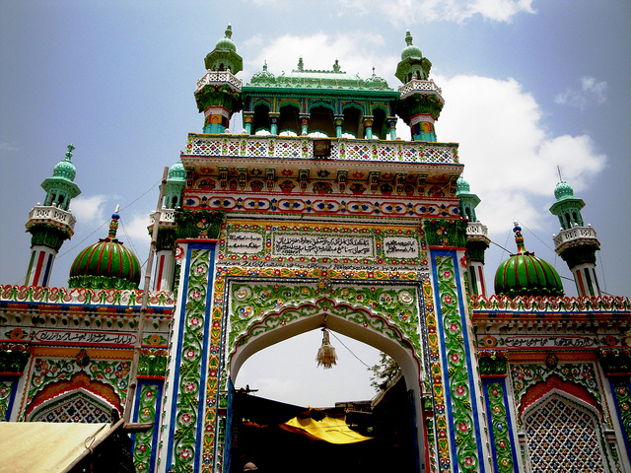Thatta's Makli Necropolis, a UNESCO World Heritage Site, is site of one of the world's largest cemeteries and has numerous monumental tombs built between the 14th and 18th centuries designed in a syncretic funerary style characteristic of lower Sindh. In Pakistan’s southern province of Sindh lies one of the largest necropolises in the world — the **MAKLI** graveyard**,** home to nearly half a million tombs and graves of royals, sufi saints and others, spread over an area of approximately 8km in which one of the spiritual Tomp is **Hazrat Syed Ashabi Shah** (Rahmatullah Alaih) Makli Thatta.(2)

His ancestors are from Hazrat Shah Abdul Qadir Jillani (Rahmatullah Alaih ).

The city's 17th century Shah Jahan Mosque is richly embellished with decorative tiles, and is considered to have the most elaborate display of tile work in the South Asia (3).

**• Understand the Historical, Geographical recreational and Economic potential aspect of the site.**

**Geography :**

Thatta's Geology is characterized by volcanic and sedimentary rocks that are similar to those in the Indus plain, and Thar Desert. Soil types in the region are silty, with some clay as well. Much of the soil is exposed to salinization from the Arabian Sea.

Vegetation in Thatta is characterized by mangrove forests in the coastal region, with tropical-thorny shrubs elsewhere.(1)

**History :**

The Young Muslim hero, the Arab Conqueror, Muhammad bin Qasim captured the region in 711 CE after the defeating the local Raja in a battle north of Thatta. Muhammad bin Qasim’s conquest of Sindh carried countless Political , Social , Religious and Academic consequences.

After this, Thatta was Governed by the Mughal Empire based in Delhi, which lead to a decline in the city's prosperity as some trade was shifted towards other Mughal ports. In 1626, Shah Jahan's 13th son, “Lutfallah”, was born in Thatta. The city was almost destroyed by a devastating storm in 1637. As a token of gratitude for the hospitality he had received in the city while still a prince, Shah Jahan bestowed the Shah Jahan Mosque to the city in 1647 as part of the city's rebuilding efforts, although it was not completed until 1659 under the reign of his son Sultan Aurangzeb Alamgir (Rahmatullah Alaih). Mughal Emperor Aurangzeb Alamgir (Rahmatullah Alaih) himself had also lived in Thatta for some time as governor of the lower Sindh.(4)

**Economic potential :**

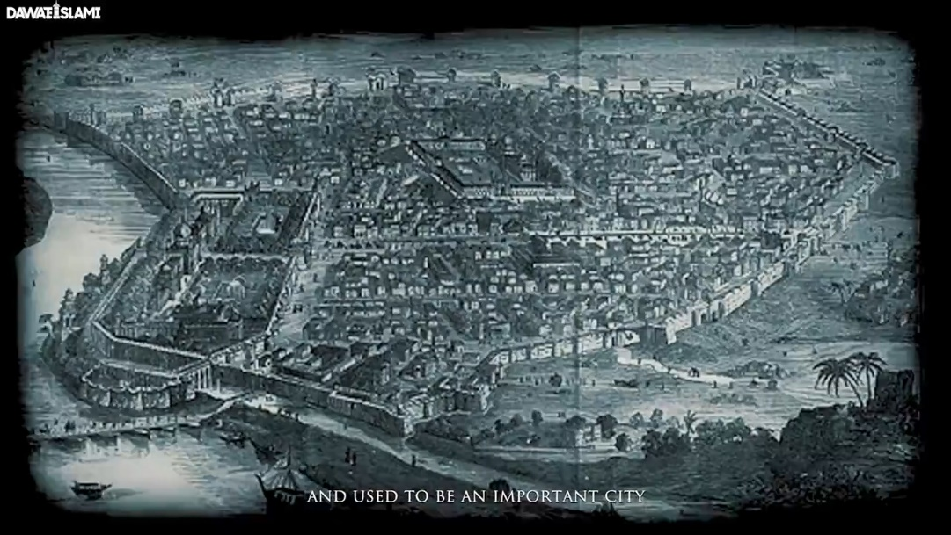If we Delve into the Recent Past and do some research, we will find that Thatta was an Economic Hub and used to be an important city where Education, Economy, and many other things Flourished.

But if we go there now, we see a total contrast. Neither those Educational institutions, Colleges, and Universities remained , Nor did that Economic flow persist.

• **What are the features that attract to this city?**

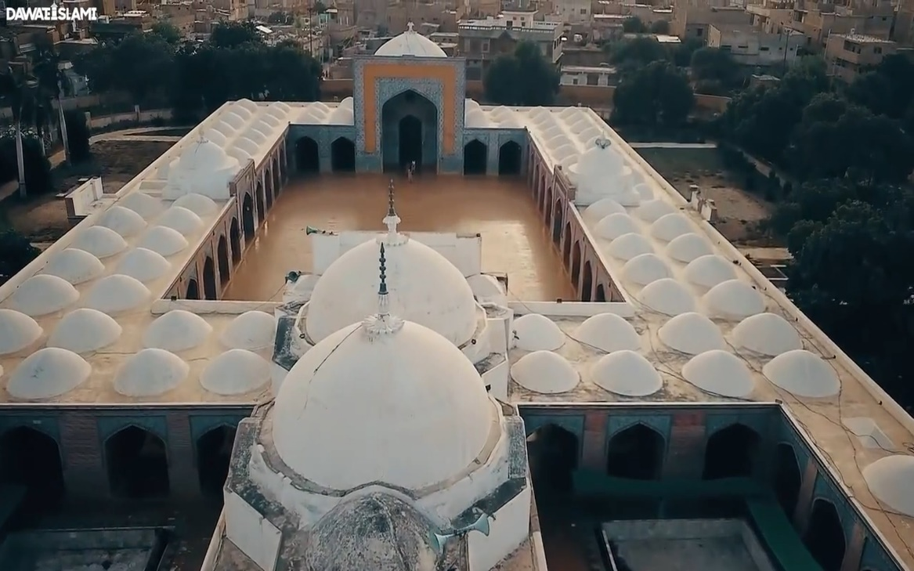The Biggest Masjid in Pakistan in terms of DOMES (99 or 100 DOMS) is Jami’ Masjid Thatta which is also known as “**Shah Jahan Masjid**” and “**Badshahi Masjid**”.

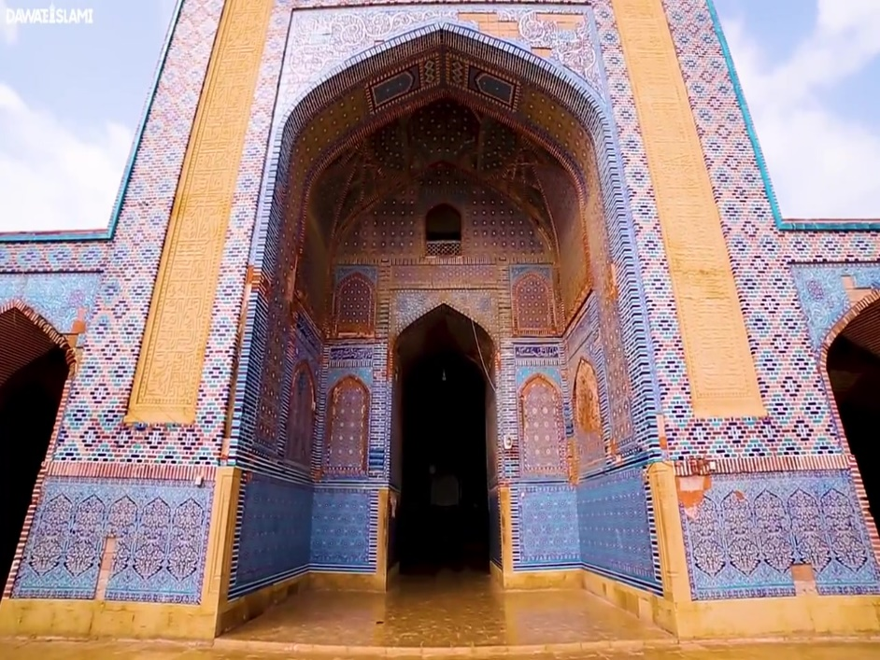The MUGHAL Emperor **Shah Jahan** had this Masjid built that’s why it became Renowned with his very Name. It is said that Shah Jahan Masjid in Thatta is built at the same place where Shah Jahan used to offer Salah in a small Masjid during the period of his Exile.

This Monumental Masjid in Thatta is a Beautiful Model of Iranian Architecture. This Masjid is indeed an amazing role Model of Beautiful Skill-Work, Elegance and Arrangement of Colours.

The changes that took place during the construction of Sindh and beginning of the Islamic Era. Their Foundations were provided by the Central Asian Lands of BADAKHSHAN, HERAT, and IRAN. Whereas the Architecture and Sculpting have their origins here.

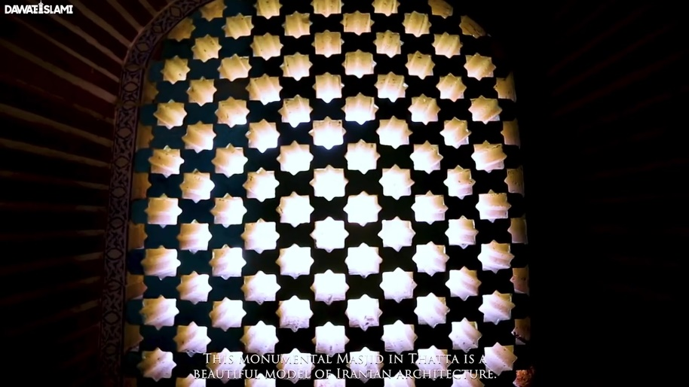

In addition to Beauty, A unique Fact about this Masjid

is that it is so Big that 20,000 people can offer Salah in

it at a Time. Loud Speakers are not needed in that Masjid.

If you are Leading Salah or Delivering a speech, it is such a

Huge Masjid and yet no loudspeakers are needed, and the

sound naturally reaches Everyone.

**Who was Leading this Stunning Architecture ?**

Mir Abul Baqa Ameer Khan s/o Nawab Abul Qasim Namkeen Bikhri who was a Subedar appointed by the Thatta Government, started the Construction of this Masjid on the orders of Shah Jahan. And the Construction of this Magnificent Masjid was completed in 1647.

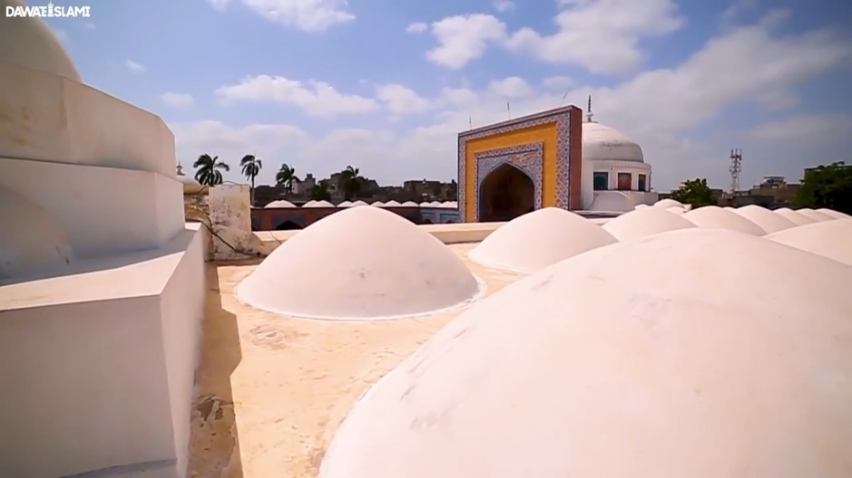

The 99 or 100 Domes of this Splendid Masjid further increase its Beauty. As per that time, 900,000 Rupees were spent on the Construction of this Masjid which Amount to a huge sum as per the present time. After the First Construction, during the Last Year of Shah Jahan’s Reign. The Mughal Emperor in 1657, Mir Sayyid Jalal Razavi had the Floor Constructed. During the Reign of Aurangzeb Alamgir (Rahmatullah Alaih) some repairs and additional Construction work were Carried out in the Masjid. In 1812, during the time of Mir Murad Ali as well, some repairs were made. Then in 1855, 1894, and then the last Construction work took place in 1975 in which a boundary wall was built for the Masjid. A Splendid Garden was Built in front of the Masjid and Wonderful Mihrab was also Constructed because of which the Beauty of this Masjid further increased.

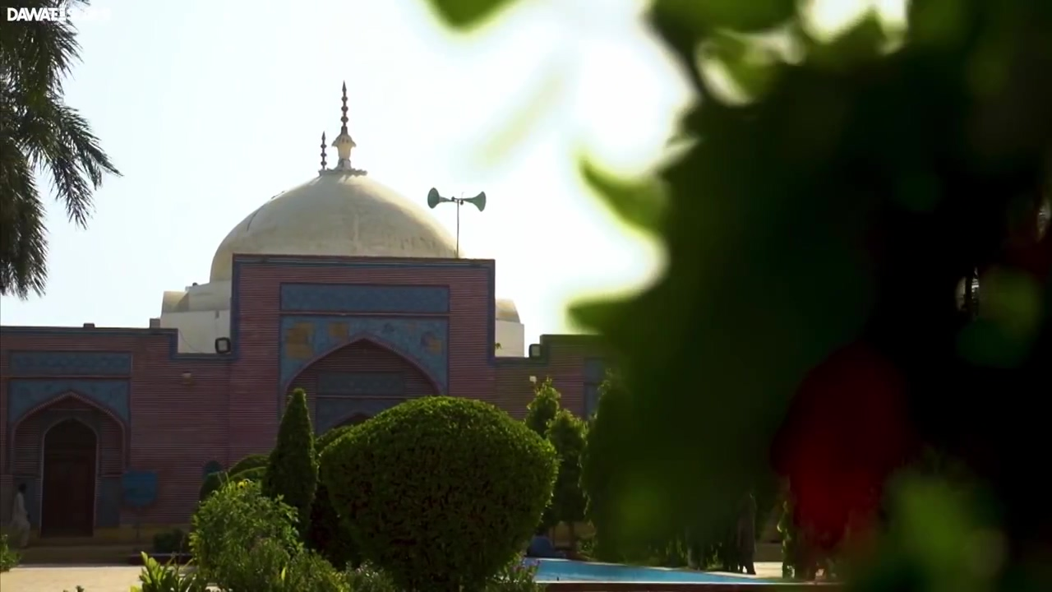

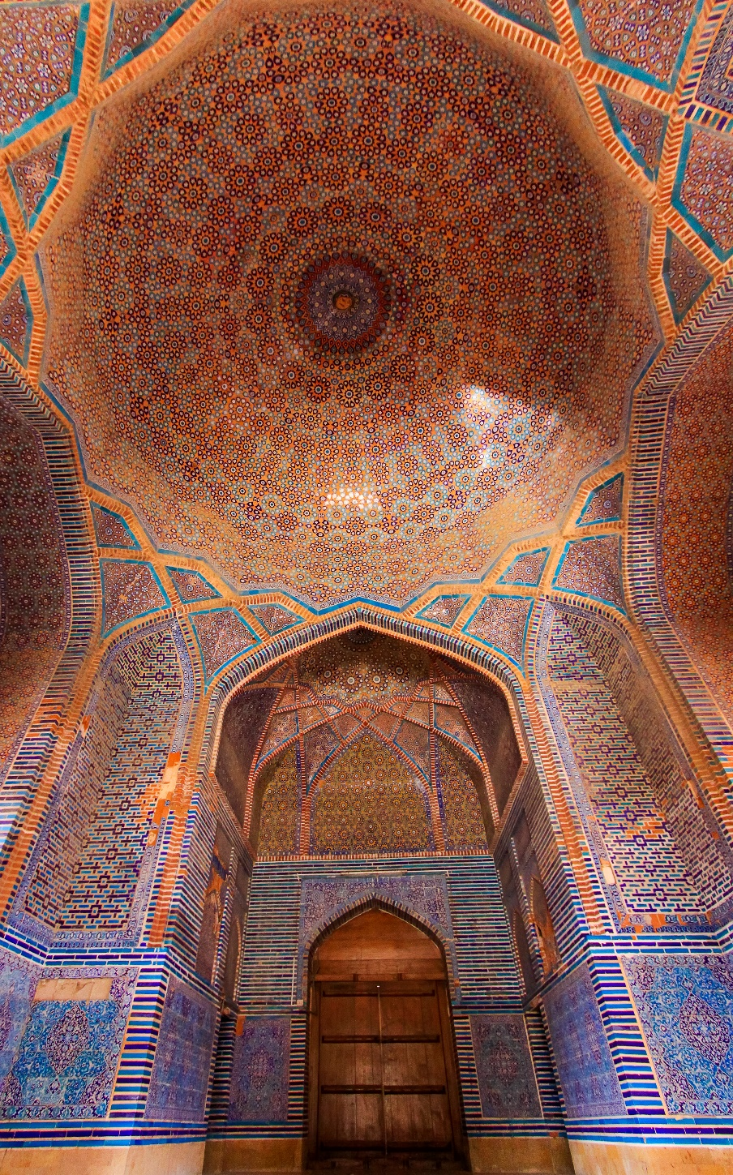

If we Look at the Architecture of the Masjid, we will find the influence of Turkey, Iran, Egypt and India. The Craftsmen of Brickwork took this art to perfection by inscribing, The Quran Verses on the Bricks. The Craftsmen made its Beauty Everlasting by Engraving the CALLIGRAPHY done on paper on the Hard Bricks. The Texts in the Masjid contain Three types of Fonts:

1) NASKH.

2) SULUS.

3) NASTALIQ.

This Building is not Like other Mughal Royal Masjid example: The Masjid on AGRA , FATEHPUR, DELHI and LAHORE which are made of Rocks, Rather this Masjid is Built from Beautiful local Bricks and its Beauty are the Glazed Tiles of Thatta which display the perfection of Glazed-Tile Work.

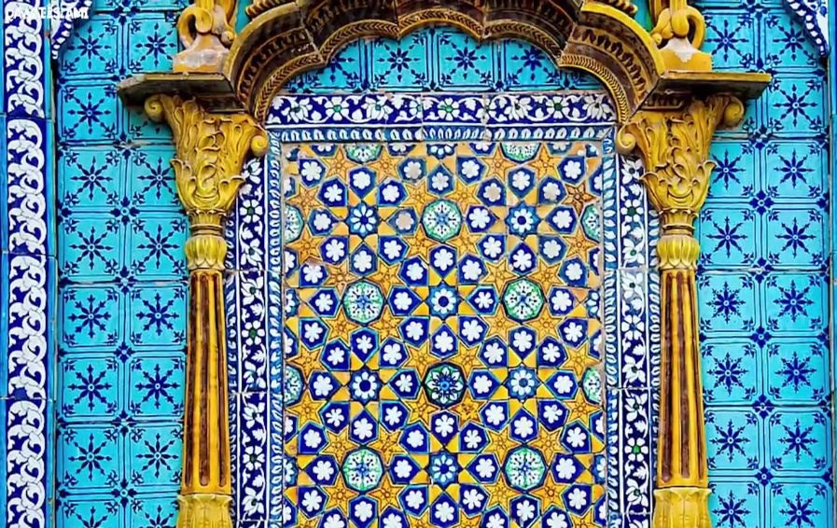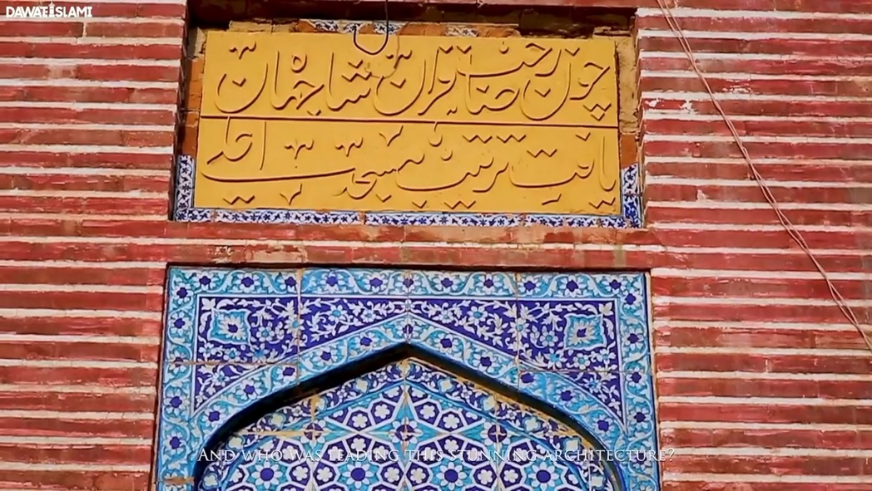

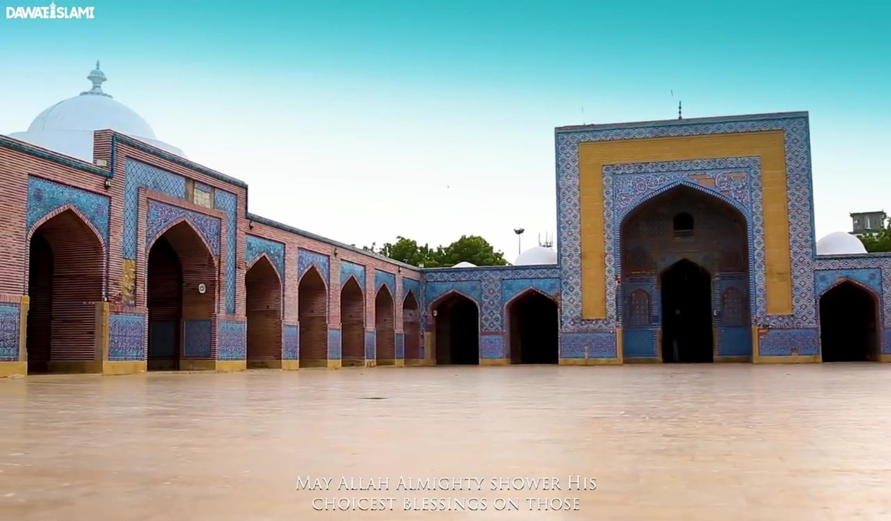May ALLAH ALMIGHTY shower His Choicest Blessings on those who Thought about the Construction and Beautification of this Masjid and Executed it and Those who worked extremely Hard here in all Four Seasons and Brought about a Sacred Beauty! (Ameen)

**• In the last how we can improve and promote tourism in Pakistan.**

This is a century of tourism, scientific and technological knowledge, and exploring world history. Developed countries provide attractions and facilities to the tourists who would like to visit their land. Pakistan has undoubtedly huge fine resorts for excursion, sight-seeings, historical places and abundant natural beauty. Yet, the tourism sector lacks the proper attention of the government. As a consequence, Pakistan gets a poor number of foreign tourists.

* The Government of Pakistan should promote tourism with sufficient publicity.
* There should be more facilities; good hotels, comfortable surroundings, proper transport.
* The government should also launch an e-portal for visitors` bookings. Pakistan Tourism Development Corporation (PTDC) should also strive its best to promote tourism.

**{ References }**

(1) <https://en.wikipedia.org/wiki/Thatta>

(2) <https://www.dawn.com/news/1263524>

(3) Khazeni, Arash (2014). Sky Blue Stone: The Turquoise Trade in World History. California Press.

(4) Asher, Catherine (1992). Architecture of Mughal India, Part 1, Volume 4. Cambridge University Press.